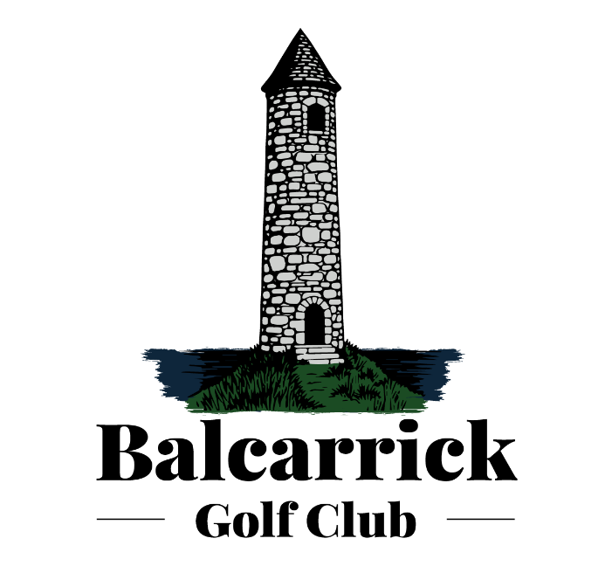

MANAGEMENT COMMITTEE ANNUAL REPORT

7TH December 2025

Another year is drawing to a close. We had a great year of golf and this report summarises the great work and progress throughout the year. We were blessed with good weather which added to our enjoyment of golf.

EGM – 29th March 2025

A special EGM was held with a presentation of the Club status and Strategy overview, the purchase of the practice area the vote on the proposal of the two alternate nine hole courses. It was a very lively meeting in the Shoreline Hotel in Donabate and the decision taken was to retain the current course.

INTER CLUB COMPETITIONS

There were memorable moments and great achievements made with the progress through the various stages of the Inter Club competitions with the submission of Ladies and Men’s teams.

The Ladies entered a team in the Ladies Leinster Challenge and were successful in reaching round 4. Ladies also entered Women’s Minor Foursomes.

The Men entered the Senior Cup, the Junior Cup, Barton Sheild and the Leinster Trophy. The Men’s team in the Senior Cup and the Barton Shield reached the semi-final. Junior Cup, Leinster North reach Round 4. The Leinster Men’s Trophy our team reached round 2. Pierce Purcell, Leinster North round 1.

The club also enter a team into the mixed foursomes.

Well done to all of the teams. Thank you for putting yourself forward and entering the competitions. Thank you to all of the managers and assistant managers for arranging the matches. Thanks you also for arranging the practice at home and away and the caddies who supported the player through their match.

Captains’ and President’s events

Lady Captain Helen’s day was held on the 5th July and the overall winner for 7 day Ladies was Grace Conway. Miriam Grealey was the winner for 5 day members, with Ciaran Murphy winner the Lady Captain’s prize for Men. It was very well attended and a great day was had by all.

The Past Lady Captains from clubs across Leinster was held in Balcarrick in May. There were great complements about our course. 88 ladies took part.

Men’s Captain Paddy’s day was on the 12th July and had a great turnout. The overall winner was Ciaran Murphy. Sheila Crilly won the Captain’s prize for Ladies.

President Marie held her day on the 14th July and this was also a great day.

COMPETITIONS

Various other fund raising competitions were also held, which included:

- Stephen Ennis Memorial on 1st August.

- Jack Collins memorial on the 30th May.

- On the May bank holiday, a Charity Day for St Francis Hospice in Raheny. Well done to all those who attended and a cheque for €5,200 was presented to St. Francis Hospice.

- Course Fundraiser in September and thank you to all who played and bought tickets for the raffle. An amount of €4,700 was raised and it was used to resurface the carpark which was badly needed. Thanks to Stewy Mangan for managing the project.

- We also had the fun competitions of the 9-n-dine organised by Pat Cluxton which is always a great night. Thank you Pat, Clare and family for all you do.

COURSE PACE OF PLAY AND ACCESS

We had some good initiatives this year to improve the pace of play. A Pace of Play document was distributed to all members and hopefully this has improved the time factor when out playing.

The membership and fees sub-group developed an initiative to tackle the people accessing the course in the early evening and by-passing the Pro Shop. A number of members monitored the course in July and it was agreed that this initiative was a success. It will continue into the future.

COURSE SUB-COMMITTEE

Our Course Sub-Committee have been doing a great job over the year with developing recommendations for the Head Greenkeeper, Martin Sheridan, and course staff to implement. New flags have been erected, a new welcome sign has been constructed, with new artwork. The sub-committee work closely with the Head Greenkeeper with new ideas to ensure that the course is in tip top condition.
I think we can all agree that the course is in great condition and we receive many compliments.
Thanks to all involved.

MARKETING

The marketing sub-committee have been busy this year and have produced new logos’ and our new website is now nearly ready for launching. Please engage with the social media marketing items by liking and sharing our postings, by doing this you are helping the growth of your club.

JUNIOR SECTION

The Child Safeguarding policy has been up in line with Golf Ireland recommendations. We now have our Child Club Officer (CCO) who is Stephen McCleary and Designated Liaison Office who is Frances Talbot.
The CCO is key to developing this section. Stephen together with our Golf Pro Eoin will be working together in 2026 with some great initiatives to develop the junior section.

PRO SHOP

A sub-committee was set up to find and appoint a new Golf Professional for Balcarrick arising from Iarlaith Keane’s decision to move to another club.
We would like to express out thanks of behalf of all our members for Iarlaith’s contributions and commitment to Balcarrick over many years, we wish him well in his new role.

We are delighted to welcome our new Pro Eoin Gibbons who has come with great enthusiasm and great ideas to move our club forward and increase membership. Eoin has joined the marketing sub-group as he comes with great knowledge and experience in this area.

HON TREASURERS MESSAGE

The Accounts have shown a great upturn in fortune for the club after a difficult few years where we were at low or break-even surplus for the year. The availability of the course has allowed us to generate additional revenues on Green Fees, Societies and Competition fees, coupled with a focus on reducing costs where possible.
This has allowed us to invest in course equipment and improvements to both the course and clubhouse facilities, but there is still lots more to do.

For the coming year, I am proposing that Membership sub rates will remain the same with the only adjustment being a smoothing out of underage rates over the lifetime of this category. It is important to note that this is neither an increase or decrease, but rather a better pathway to ensuring that these underage members become full fee paying members & remain with Balcarrick GC for the long term – see below for full details :-

Age | 18 | 19 | 20 | 21 | 22 | 23 | 24 | 25
Yearly Subs | €155.00 | €155.00 | €250.00 | €345.00 | €440.00 | €465.00 | €465.00 | €465.00

26 | 27 | 28 | 29 | 30 | 31 | 32 | 33 | 34
€565.00 | €665.00 | €765.00 | €815.00 | €815.00 | €915.00 | €1,020.00 | €1,125.00 | €1,230.00

I will also be reviewing the competition fees with the view to lowering them down to €5 per competition over the coming months & years (majors notwithstanding) but this will be dependent on membership numbers increasing and an upturn on competition entry – this review will be ongoing throughout the year. An examination of prize values will also form part of this review.

BEHIND THE SCENES

Some of our achievements behind the scenes this year include:

- essential repairs to the clubhouse roof;
- a new boiler tank;
- new furniture in the restaurant;
- new machinery for our green-keeping staff.
- Restoration of some of our fencing;
- Painting of the fences, verandah and surrounds;
- Grant applications.

WHAT’s COMING UP

- The refurbishment of the men’s toilets and locker room expected early next year.
- New golf buggies to arrive soon, following negotiations and a new deal struck with a new provider.,

CATERING

Jacinta has advised us of her intention to retire at the end of this year. Jacinta has been with Balcarrick for 15 years and has always provided us with high quality food, served with a smile. Our thanks to Jacinta for all her hard work over the years.

NEW MEMBERS

Finally we welcome all our new members who joined to this year. You are very welcome and we hope your golf goes from strength to strength.

To all members, we have a lot more to do in the club and of course we cannot make more improvements without your help. No need to join a committee but join a sub-committee or group and help make improvements happen.

THE COURSE AND SURROUNDS

This has been a very busy year for all committees, sub-committees, and volunteers.

There has been a lot of great work on the course with the planting of new trees and the removal of briars around the course. In summary, the entrance hedges have been trimmed, weeds have been pulled, fences have been repaired and painted, the patio has been cleaned and painted, the beautiful flowers have been planted pruned and watered, rooms have been painted, and so much more.

We wish to express our gratitude to all our staff, Martin and his team, Alex our Office Administrator, and all the various volunteer members who have given their time to contribute to all that has been done in 2025.We have several volunteer groups who need your help please do come forward to help make your club better.

Hon Secretary
On behalf of the Management Committee
December 2025

