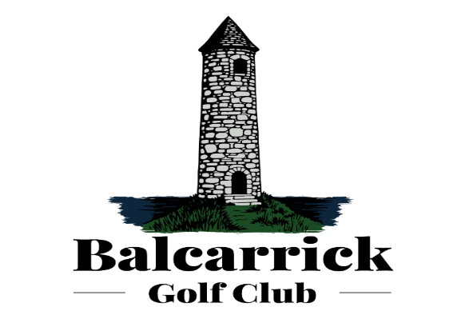
Joint Club

Committee Nomination Form
A.G.M. 2025

Position nominated for: _____________________________
Name of Nominee: _____________________________
Proposed by: _____________________________
Seconded by: _____________________________
Date: _____________________________

Please submit to the Hon. Secretary by 23rd November 2025 or by email to:
honsec@balcarrick.com

Alternatively, deliver to the Office addressed to the Honorary Secretary by 23rd November 2025

